Mobile Failures Report
From Barbados and Jamaica
ASAP 7.0.2 – JAMU66

Week 32
August 06th to August 12th, 2018

August 13th, 2018

Contents

1 Percentages for all mobile activations, changes and deactivations Barbados 3
2 Percentages for all mobile activations, changes and deactivations Jamaica 4
3 Top 5 failure issues Barbados 5
4 Top 5 failure issues Jamaica 6
5 Failure numbers Barbados 7
6 Failure numbers Jamaica 8

Percentages for all mobile activations, changes and deactivations Barbados

 | TOTAL | COMPLETE | FAILED | % Total | % COMPLETE | % FAILED
ACTIVATE | 40 | 12 | 28 | 0% | 30% | 70%
DEACTIVATE | 8634 | 8629 | 5 | 49% | 100% | 0%
MODIFY | 9114 | 9067 | 47 | 51% | 99% | 1%

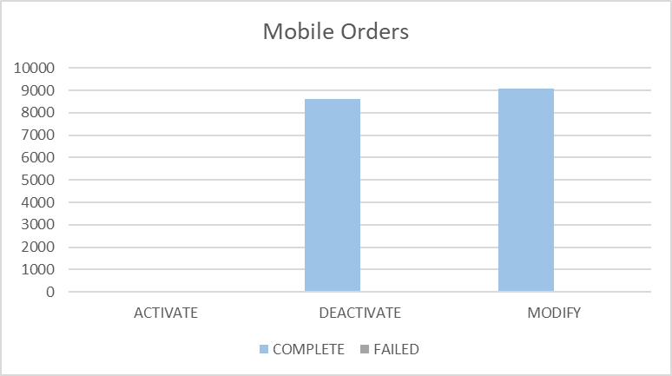

Percentages for all mobile activations, changes and deactivations Jamaica

 | TOTAL | COMPLETE | FAILED | % Total | % COMPLETE | % FAILED
ACTIVATE | 2342 | 2336 | 6 | 11% | 100% | 0%
DEACTIVATE | 5994 | 5989 | 5 | 27% | 100% | 0%
MODIFY | 13713 | 13679 | 34 | 62% | 100% | 0%

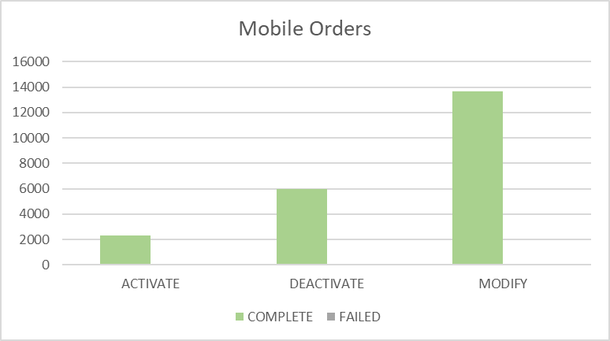

Top 5 failure issues Barbados

14 | EMA_RESP_35101:Missing or invalid parameter.
9 | EMA_RESP_14:The Specified MSISDN is not defined
6 | NGVM_ETTY_DSNT_EXST:The specified Mailbox ID does not exist on the Comverse Voicemail platform.
5 | EMA_RESP_2:The Specified MSISDN is already defined with a different IMSI
5 | FAIL:No such object
3 | EMA_RESP_13:The Specified IMSI is not defined
3 | EMA_RESP_35105:The subscriber already exists.
1 | EMA_RESP_35106:The subscriber does not exist.
1 | EMA_RESP_3005:Invalid Argument or out of Range

Top 5 failure issues Jamaica

8 | NGVM_ETTY_DSNT_EXST:The specified Mailbox ID does not exist on the Comverse Voicemail platform.
5 | FAIL:No such object
5 | EMA_MISS_REQ_PARAM:Mandatory parameter is missing from work order
5 | EMA_RESP_1:The Specified IMSI is already defined
4 | SAPC_PROVCARTEXP:The NE was denid due to provisioning cartridge exception
2 | SAPC_EXCEPTION:The NE was denid due to general exception
1 | EMA_RESP_35101:Missing or invalid parameter.
1 | EMA_RESP_6:Subscriber authentication data not found
1 | EMA_RESP_27:Operation not allowed due to interaction
1 | NGVM_SUBS_USED:The subscriber key (TelephoneNumber, ExternalSubscriberId, etc.) is already in use by another subscriber.
1 | EMA_RESP_1001:External system communication link failure.

Failure numbers Barbados

SRQ_ID | WO_ID | WO_STATUS | MSISDN
938716 | CIS:BAR:23726651:172.21.64.13:25001:1533668317421 | FAILED | 12462302182
938736 | CIS:BAR:23726768:172.21.64.13:25001:1533668379318 | FAILED | 12462302182
949334 | OCA-5906 | FAILED | 12462308330
949349 | OCA-5907 | FAILED | 12462308330
949620 | OCA-5913 | FAILED | 12462308330
951706 | CIS:BAR:23752324:172.21.64.13:25001:1533751209868 | FAILED | 12462538646
953208 | CIS:BAR:23755297:172.21.64.13:25001:1533757080566 | FAILED | 12462503711
953277 | CIS:BAR:23755473:172.21.64.13:25001:1533757469835 | FAILED | 12462400558
953290 | CIS:BAR:23755514:172.21.64.13:25001:1533757540681 | FAILED | 12462400558
953319 | CIS:BAR:23755581:172.21.64.13:25001:1533757693634 | FAILED | 12462400558
953335 | CIS:BAR:23755617:172.21.64.13:25001:1533757789585 | FAILED | 12462400558
954116 | OCA-5938 | FAILED | 12462837305
954530 | OCA-5952 | FAILED | 12462837305
954570 | OCA-5954 | FAILED | 12462837305
958094 | CIS:BAR:23758358:172.21.64.13:25001:1533821108306 | FAILED | 12462400558
959626 | OCA-5957 | FAILED | 12462300165
964196 | CIS:BAR:23758431:172.21.64.13:25001:1533836702728 | FAILED | 12462503678
964472 | OCA-5980 | FAILED | 12462309589
964667 | OCA-5991 | FAILED | 12462306795
964668 | OCA-5992 | FAILED | 12462306795
964683 | OCA-5993 | FAILED | 12462306795
965561 | CIS:BAR:23758465:172.21.64.13:25001:1533845247530 | FAILED | 12462363260
965573 | CIS:BAR:23758470:172.21.64.13:25001:1533845296096 | FAILED | 12462363260
965754 | CIS:BAR:23758492:172.21.64.13:25001:1533846617122 | FAILED | 12462314424
969180 | CIS:BAR:23759260:172.21.64.13:25001:1533904983891 | FAILED | 12462340233
969184 | CIS:BAR:23759267:172.21.64.13:25001:1533905065080 | FAILED | 12462340233
969273 | CIS:BAR:23759269:172.21.64.13:25001:1533905175792 | FAILED | 12462340233
970223 | CIS:BAR:23759312:172.21.64.13:25001:1533914816446 | FAILED | 12462340233
970235 | CIS:BAR:23759317:172.21.64.13:25001:1533914934596 | FAILED | 12462340233
970425 | CIS:BAR:23759333:172.21.64.13:25001:1533916228063 | FAILED | 12462424759
971482 | OCA-6056 | FAILED | 12462434931
971699 | CIS:BAR:23759378:172.21.64.13:25001:1533925117747 | FAILED | 12462420791
971699 | CIS:BAR:23759378:172.21.64.13:25001:1533925117747 | FAILED | 12462513706
971703 | CIS:BAR:23759382:172.21.64.13:25001:1533925177769 | FAILED | 12462420791
971703 | CIS:BAR:23759382:172.21.64.13:25001:1533925177769 | FAILED | 12462513706
971731 | CIS:BAR:23759386:172.21.64.13:25001:1533925222840 | FAILED | 12462420791
971731 | CIS:BAR:23759386:172.21.64.13:25001:1533925222840 | FAILED | 12462513706
971766 | CIS:BAR:23759389:172.21.64.13:25001:1533925552068 | FAILED | 12462420791
971766 | CIS:BAR:23759389:172.21.64.13:25001:1533925552068 | FAILED | 12462513706
972131 | CIS:BAR:23759430:172.21.64.13:25001:1533928095828 | FAILED | 12462424759
972137 | CIS:BAR:23759440:172.21.64.13:25001:1533928171637 | FAILED | 12462424759
972223 | CIS:BAR:23759453:172.21.64.13:25001:1533929000821 | FAILED | 12462426450
972238 | CIS:BAR:23759460:172.21.64.13:25001:1533929179701 | FAILED | 12462420791
972238 | CIS:BAR:23759460:172.21.64.13:25001:1533929179701 | FAILED | 12462513706
973379 | OCA-6081 | FAILED | 12462301166
973759 | OCA-6084 | FAILED | 12462301166
973759 | OCA-6084 | FAILED | 12462337192
973810 | OCA-6085 | FAILED | 12462301166
973810 | OCA-6085 | FAILED | 12462301166
973836 | OCA-6086 | FAILED | 12462301166
973846 | OCA-6087 | FAILED | 12462301166
975073 | OCA-6090 | FAILED | 12462301166
975144 | OCA-6091 | FAILED | 12462301166
975144 | OCA-6091 | FAILED | 12462337192
975294 | OCA-6096 | FAILED | 12462301166

Failure numbers Jamaica

SRQ_ID | WO_ID | WO_STATUS | MSISDN
925371 | CIS:JAM:185264354:172.21.64.17:25007:1533566949641 | FAILED | 18765090248
925408 | CIS:JAM:185264429:172.21.64.17:25007:1533568204605 | FAILED | 18769097457
925416 | CIS:JAM:185264446:172.21.64.17:25007:1533568634920 | FAILED | 18765409926
925599 | CIS:JAM:185264773:172.21.64.17:25007:1533575053433 | FAILED | 18765359922
925679 | CIS:JAM:185264929:172.21.64.17:25007:1533577980136 | FAILED | 18764794450
930735 | CIS:JAM:185308310:172.21.64.17:25007:1533642459149 | FAILED | 18769971624
933254 | CIS:JAM:185309009:172.21.64.17:25007:1533650456510 | FAILED | 18768226735
933254 | CIS:JAM:185309009:172.21.64.17:25007:1533650456510 | FAILED | 18768342296
933790 | CIS:JAM:185309690:172.21.64.17:25007:1533652153365 | FAILED | 18769197714
943860 | CIS:JAM:185332407:172.21.64.17:25007:1533694282202 | FAILED | 18768312789
943861 | CIS:JAM:185332409:172.21.64.17:25007:1533694335009 | FAILED | 18768312789
951138 | CIS:JAM:185384896:172.21.64.17:25007:1533748311191 | FAILED | 18767743890
952452 | CIS:JAM:185387448:172.21.64.17:25007:1533753429936 | FAILED | 18768035355
953775 | CIS:JAM:185389868:172.21.64.17:25007:1533759955118 | FAILED | 18767826843
953799 | CIS:JAM:185389919:172.21.64.17:25007:1533760096993 | FAILED | 18768279237
954303 | CIS:JAM:185391056:172.21.64.17:25007:1533761597211 | FAILED | 18767717079
954312 | CIS:JAM:185391077:172.21.64.17:25007:1533761656684 | FAILED | 18767717079
955013 | CIS:JAM:185393398:172.21.64.17:25007:1533768520248 | FAILED | 18763224854
964522 | CIS:JAM:185475077:172.21.64.17:25007:1533838966161 | FAILED | 18767970991
965281 | CIS:JAM:185477928:172.21.64.17:25007:1533843596999 | FAILED | 18765329276
966562 | CIS:JAM:185482211:172.21.64.17:25007:1533852785968 | FAILED | 18763278694
966565 | CIS:JAM:185482217:172.21.64.17:25007:1533852872860 | FAILED | 18763278694
970220 | CIS:JAM:185494498:172.21.64.17:25007:1533914804163 | FAILED | 18763261873
971751 | CIS:JAM:185498199:172.21.64.17:25007:1533925392263 | FAILED | 18768200517
972093 | CIS:JAM:185498948:172.21.64.17:25007:1533927714897 | FAILED | 18767752550
977456 | CIS:JAM:185520642:172.21.64.17:25007:1534000510779 | FAILED | 18769090027
977456 | CIS:JAM:185520642:172.21.64.17:25007:1534000510779 | FAILED | 18769090566
977466 | CIS:JAM:185520675:172.21.64.17:25007:1534000574786 | FAILED | 18769090027
977466 | CIS:JAM:185520675:172.21.64.17:25007:1534000574786 | FAILED | 18769090566
977474 | CIS:JAM:185520695:172.21.64.17:25007:1534000711978 | FAILED | 18769090027
977474 | CIS:JAM:185520695:172.21.64.17:25007:1534000711978 | FAILED | 18769090566
977487 | CIS:JAM:185520719:172.21.64.17:25007:1534000892438 | FAILED | 18769090027
977487 | CIS:JAM:185520719:172.21.64.17:25007:1534000892438 | FAILED | 18769090566
978790 | CIS:JAM:185524137:172.21.64.17:25007:1534017319416 | FAILED | 18768336447
979178 | CIS:JAM:185525479:172.21.64.17:25007:1534025242752 | FAILED | 18763277781
979703 | CIS:JAM:185526997:172.21.64.17:25007:1534037084757 | FAILED | 18765440978
979706 | CIS:JAM:185527003:172.21.64.17:25007:1534037170349 | FAILED | 18765440978
981375 | CIS:JAM:185628028:172.21.64.17:25007:1534084733387 | FAILED | 18763278694
981516 | CIS:JAM:185628593:172.21.64.17:25007:1534096930337 | FAILED | 18763106093

